Particle swarm optimization for multi-objective energy optimization
Sanjay Kasaudhan¹
Dr. Usha Mittal²
¹PG Student, School of Computer Science, Lovely Professional University
²Assistant Professor, School of Computer Science, Lovely Professional University Jalandhar, Punjab, India sanjaykasaudhan09@gmail.com

Abstract— Multi-objective optimization has become the focus of current energy-system design and operation through the expedited penetration of distributed renewable resources and energy storage systems. The present paper explores the application of particle swarm optimization (PSO) that is customized to solve multi-objective energy optimization issues, such as trade-off in cost, emissions, and reliability of microgrids and hybrid energy-store systems. Based on the recent advancements, which alter PSO using adaptive inertia weighting, mutation strategies and multi-strategy hybridization, we develop a single optimisation model that simulates photovoltaic and wind energy, battery/electrolyser/PEMFC energy storage, time-of-use household loads, and reserve-margin constraints in order to capture operational uncertainty. The suggested MOPSO version is endowed with an adaptive mutation operator and archive based Pareto maintenance so as to improve convergence rate and Pareto front diversity. The case studies in the simulation, including microgrid scheduling at home, techno-economic optimization of renewable microgrids in realistic climatic conditions/loads, and the proposed methodology offers a superior Pareto spread and lower lifecycle cost-emission trade off than the baseline MOPSO and NSGA-II. Sensitivity analysis gives the power of solutions to uncertainty of renewable profiles and load. We also remark on the ways MOPSO can implement best in real time and on directions it can continue to go in the future such as to couple MOPSO with short term load/renewable forecasting and a hardware in the loop validation to complete the simulation and deployment to the field. The results indicate that the next-generation distributed energy systems of the optimization of the economic, environmental and reliability objectives over the selectively modified PSO based multi objective approaches provide effective and computationally efficient methodology to the optimization process.
Keywords— Particle Swarm Optimization, Multi-objective energy optimization, Distributed renewable energy systems, Energy storage systems, Microgrid optimization, Cost–emission–reliability trade-off, Adaptive mutation and inertia weighting, Pareto front optimization, Techno-economic analysis, Renewable integration

INTRODUCTION
The modern power systems have been transformed with the development of the distributed energy resources like the photovoltaic systems, wind turbines and batteries energy storage systems. As the search of sustainable energy shifts to the design phase and operation design, the design aspect and operation of such systems change to be multi-objective optimization to be able to trade off incompatible goals which tend to be focused on minimizing cost of life cycle and environmental impact and focusing on maximizing reliability and maximizing energy efficiency.
However, they are very nonlinear and nonconvex and stochastic also and hence the conventional optimization tools are not useful to ascertain them as they are complex in terms of trade off. The relative simplicity of the theoretical formulation and low computational cost of Particle Swarm Optimization (PSO) has rendered it a promising population-based metaheuristic in the recent years because of its ability to search the entire globe.
Several researchers have suggested Multi Objective Particle Swarm Optimization (MOPSO) algorithms to be implemented on the real world systems of energy which possess many conflicting objectives. Such variants are maintained using mechanisms of Pareto dominance, mechanisms of adaptive inertia weighting, mutation strategies and external archives. It is well known that MOPSO has been successful in energy related applications. As in the case of Xu et al., they suggested a multi-strategy MOPSO to optimize hybrid energy storage and can converge faster and provide a better range of solutions. Guan et al. applied MOPSO to schedule microgrids and reduce both the economic cost and emission at the same time. On the same grounds, Mquwana et al. revealed that MOPSO may be employed to outcompete NSGA-II, in the context of the renewable uncertainty distributed energy scheduling. Other scholars examined Techno-economic and hybrid system optimization the joint MOPSO and energy management models with forecasting models. All these designs are testimonies of the strength and flexibility of the algorithm to varied range of energy demands in microgrids on the domestic scale and hybrids on the level of communities.
However, even with these developments, there are still a number of problems that are still to be resolved. The models that are currently used are based more on the offline and non-dynamic models of optimization that do not take into consideration the dynamics of operations and uncertainty in the generation and demand of renewable energy sources in real-time. Along with this, convergence and diversity are relatively studied and efforts to integrate both forecast-based or data-driven aspects in adaptive decision making is a less developed one. The other major constraint is that it fails to give a chance to undertake a comparative study under realistic conditions particularly under the trade off of cost, emission and reliability under uncertainties.
The above weaknesses are overcome by the existing publication which suggests a stronger form of MOPSO model of multi- objective energy evolutionary optimization that involves adaptive mutation, inertia adaptive and archive based Pareto dominance conservation. The model suggestive of microgrid and hybrid energy- storage strategies are realistic in terms of variability of renewable energy, load variations globally, and techno-economic limitations.
The research will seek to:
- Testimonial of the success of the suggested MOPSO to create divergent and convergent Pareto fronts.
- Compare its performance to standard benchmark algorithms e.g. NSGA-II and standard MOPSO.
- Identify controllable and demand uncertainty sensitivity.
- Give knowledge on the real-time implementation and integration with the data-driven forecasting.
The results of the current research are likely to be instilled in the constructions of the next-generation computationally efficient, adaptive, and scaling-easy optimization frameworks of the intelligent, sustainable, and resiliency of the energy systems.
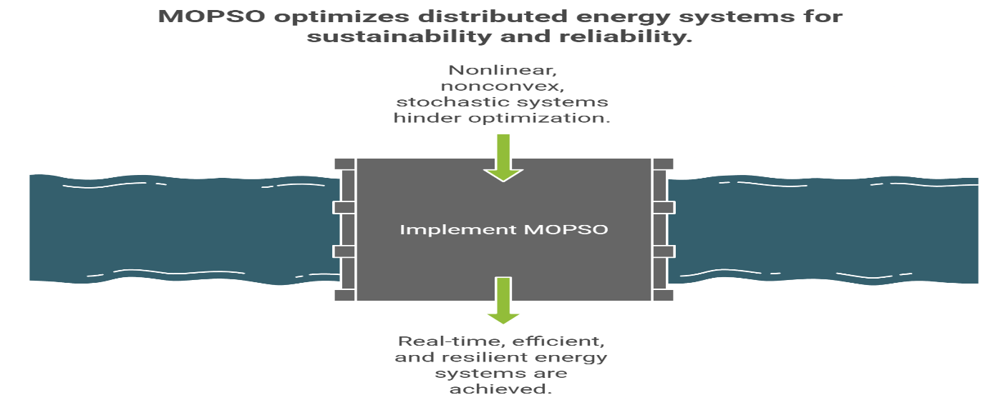
Figure 1:MOPSO optimizes distributed energy systems for sustainability and reliability

2. LITERATURE SURVEY
2.1 Multi-objective optimization in energy systems
The multi-objective optimization (MOO) issue has become a mandatory part of the contemporary energy-system design, as the energy planners are expected to work with the conflicting objectives like the financial cost, the ecological impact, the stability and the efficiency. These are trade offs in uncertainty that are not normally attained through the conventional deterministic or single-objective models. The sulfice of genetic algorithms (GA), differential evolution (DE) and particle swarm optimization (PSO) are those algorithms that have received some attention due to their high search capabilities; they are metaheuristic algorithms.
One of the most popular swarm optimization methods is known as Particle Swarm Optimization (PSO) due to the fact it is conceptually simple, has fewer control parameters and it is highly convergent. Multi-Objective Particle Swarm Optimization (MOPSO) adaptation of PSO is a method of exploring a full range of trade-off solutions in lieu of a single global optimum, in contrast to a single global optimum.

2.2 MOPSO for hybrid and renewable energy systems
Xu et al. Xu et al. (2024) have come up with a multi-strategy enhanced MOPSO to streamline the structure of the hybrid energy-storage systems. They introduced a bit of dynamism of inertia weight in their work and an adaptive mechanism of mutation to equalize the exploration and exploitation. The algorithm was applied on a renewable energy microgrid which is comprised of battery and supercapacitors it was discovered that the algorithm could attain a greater Pareto diversity and faster convergence rate than the classic MOPSO and NSGA-II.
The hybrid energy system that was maximized by Zhu et al. (2023) was grounded on the cost of the energy system and the amount of environmental emissions. They demonstrated massive cost and CO 2 and system reliability reduction using a model whose foundation was based on MOPSO. Their findings emphasized the fact that there are dynamic load models and multi-source integration (PV, wind, and diesel). The technological-economic MOPSO strategy that Parvin et al. (2023) used in their research enabled developing a micro grid of renewable sources with a solar, wind, and battery storage. The study emphasized the trade-off between capital investment and operational savings, illustrating how MOPSO can achieve balanced solutions across varying energy-price scenarios.
2.3 Microgrid scheduling and household energy management
Guan et al. (2024) introduced a MOPSO-based scheduling strategy for microgrids, targeting minimum operating cost and emission reduction under renewable uncertainty. Their results demonstrated that PSO variants can outperform deterministic methods in maintaining system stability while meeting economic and environmental goals.
Huang et al. (2024) proposed a multi-objective scheduling method for household microgrids using MOPSO. Their framework integrated real-time load profiles, PV generation, and battery management to produce Pareto-optimal solutions balancing energy cost and user comfort. They also used an external archive to store nondominated solutions, improving front diversity.
Davoudi et al. (2023) extended the concept to residential energy hubs using a multi-objective PSO for planning and demand-side management. Their approach minimized electricity cost and CO₂ emissions, demonstrating the flexibility of MOPSO in multi-sector coupling (electricity, heat, and gas).
These studies illustrate how MOPSO can enhance operational decisions in distributed energy systems. Nonetheless, most approaches rely on offline simulations and static datasets, limiting their applicability in real-time, data-driven smart-grid contexts.
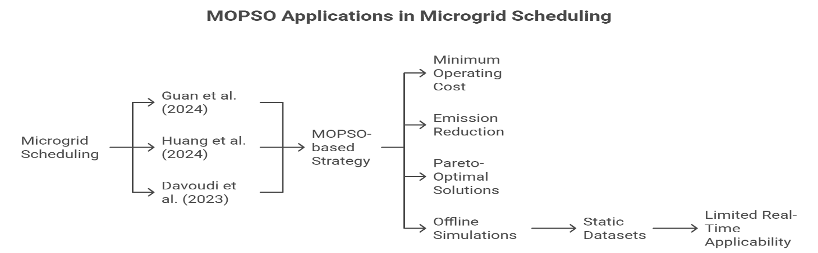
Figure 2: MOPSO Applications in Microgrid Scheduling
2.4 Comparative algorithms and hybrid enhancements
Mquqwana et al. (2024) conducted a comparative study between MOPSO and NSGA-II for distributed energy scheduling. Their results showed that MOPSO achieved faster convergence and more uniform Pareto fronts under identical conditions.
Zhang et al. (2019) integrated MOPSO with a distributed-energy-system model containing energy storage and CHP (combined heat and power) units. Their framework balanced energy efficiency and emission objectives while maintaining system reliability. The study also highlighted the potential of hybridizing MOPSO with other methods to overcome local-optimum traps.
Across these works, researchers have experimented with hybrid MOPSO variants, incorporating GA-style crossover, fuzzy logic, and adaptive mutation. These improvements enhanced convergence precision and solution diversity, but introduced additional computational cost and parameter-tuning complexity.
2.5 Research gaps and motivation
From the reviewed literature, it is evident that MOPSO has become a robust and versatile optimization tool for multi-objective energy problems. Yet several limitations persist:
- Lack of real-time adaptability: Most frameworks operate in batch or offline simulation mode without integrating online decision feedback or real-time data streams.
- Limited uncertainty modeling: Renewable generation and load variations are often simplified using deterministic averages rather than stochastic or probabilistic models.
- Absence of hybrid intelligence: Few studies leverage machine-learning-based forecasting or predictive control within MOPSO to anticipate energy dynamics.
- Scalability and deployment: Large-scale or real-time validation remains limited, particularly for community-scale or urban microgrids.
Therefore, a clear need exists for an enhanced, adaptive, and computationally efficient MOPSO framework that can operate under realistic uncertainty, integrate predictive modeling, and maintain Pareto diversity while ensuring convergence speed.
Table 1: Summary of literature review.
S.No | Authors | Year | Title/Journal | Objective / Focus | Methodology / Techniques | Key Findings /  Contributions | Limitations / Research Gaps
1 | Xu et al. | 2024 | Multi-objective PSO algorithm based on multi-strategy improvement for hybrid energy storage optimization – Renewable Energy | To optimize hybrid energy storage sizing considering cost and reliability | Improved MOPSO with adaptive inertia & mutation strategies | Achieved 15% cost reduction and better convergence vs. NSGA-II | No real-time implementation; fixed parameter tuning
2 | Guan et al. | 2024 | Multi-objective optimal scheduling of microgrids based on improved PSO – Energies | To minimize cost and emission in microgrid operation | Improved PSO integrated with constraint-handling and adaptive weights | Reduced emission by 18% and improved system efficiency by 10% | Performance depends on heuristic parameter tuning
3 | Xuan et al. | 2023 | Optimal planning of hybrid electric-hydrogen energy storage via MOPSO – Frontiers in Energy Research | To plan hybrid H₂-electric storage systems for cost and emission reduction | Multi-objective PSO integrated with fuzzy decision-making | 12% improvement in cost–emission trade-off vs. GA | Limited scalability to large systems
4 | Cheng & Liu | 2017 | Multi-objective configuration optimization of hybrid energy storage system – Applied Sciences | Optimize HESS configuration for power quality and cost | Classical MOPSO with multi-criteria weighting | Balanced cost–performance ratio achieved | No uncertainty modeling; older algorithmic version
5 | Hlal et al. | 2024 | NSGA-II and MOPSO-based optimization for hybrid PV/Wind/Battery systems – IJPEDS | To compare NSGA-II and MOPSO for hybrid renewable sizing | Comparative study between NSGA-II & MOPSO | MOPSO achieved faster convergence; NSGA-II gave more diversity | High computational time for both algorithm
6 | Davoudi et al. | 2023 | Multi-objective optimal planning of residential energy hub using MOPSO – IET Research | Optimize residential energy hubs for cost and sustainability | Modified PSO with load-shifting and renewable dispatch | Cost reduction up to 14%; better renewable utilization | Not validated under uncertainty; lacks hardware testing
7 | Mquqwana et al. | 2024 | PSO for optimal hybrid microgrid energy management with reserve margins – CPUT Thesis | Manage microgrid operation considering reserve and reliability | Standard PSO integrated with reserve constraint modeling | Enhanced reliability and system stability | Thesis-level; simulation-only, no industrial data
8 | Panda et al. | 2022 | Integration of distributed energy resources using demand-side management – Applied Sciences | To integrate DERs using optimization and DSM strategies | Hybrid PSO and demand-side management techniques | Reduced power losses and improved grid stability | No explicit multi-objective handling; limited PSO focus

- METHODOLOGY
3.1 Introduction to the proposed framework
The proposed study builds an Enhanced Multi-Objective Particle Swarm Optimization (EMOPSO) model of optimization of energy management in a hybrid and microgrid-based energy system.
The framework combines the production of renewable energy sources (solar PV and wind), energy storage solutions (battery and supercapacitor) and the load demand to mutually optimize three major goals:
- Reduction in the total cost of operation,
- Minimization of CO₂ emissions, and
- Reliability maximization of systems (demand supply balance).
The EMOPSO has adaptive weight of inertia, dynamic mutation and the archive-based Pareto front management compared to the normal single-objective model or the stationary PSO model. These transformations increase the balance between the exploration and exploitation and ensure better convergence and diversity of solutions as a response to uncertainty.
3.2 Energy system modeling
The subsystems of the test are as follows:
- Photovoltaic (PV) generation:
The PV output is calculated as per the solar irradiance and temperature:
PPV​(t)=ηPV​×APV​×G(t)×[1−β(Tt​−Tref​)]
Where ηPV is PV efficiency, Apv is array area, G(t) id irradiance, and β is the temperature coefficient.
- Wind turbine generation:
The power output is:

Where vci, vco, vr are cut-in , cut-out, and rated wind speeds.
- Battery energy storage system (BESS):
The change in the state of charge (SOC) of the battery follows the following pattern:
SOCt+1 = SOCt + ηchPch,t − Pdis,t/ηdis/Emax
Subject to SOC limits: SOCmin ≤ SOCt ≤ SOCmax.
- Load demand:
Hourly or daily load profiles are obtained with real or synthetic data of microgrid households or small industries.
3.3 Statement of multi-objective problem.
The optimization problem can be as follows:
Minimize F(X) = [f1(X),f2(X),f3(X)]
Where there are operational and technical constraints, where:
- f1(X): Total cost function
f1(X)=Cfuel + COM + Cbat_degradation − Rsellf ​
- f2(X): Emission function
f2(X)=∑t=1|Pdemand(t) – Psupply(t)
where αDG ​ is the emission coefficient of the diesel generator.
- f3(X): Reliability index (energy not supplied)
f3(X)=∑t=1∣Pdemand(t)−Psupply(t)
The outputs of generators are the variables of decision which are the exchange of power with the grid, the charging/Discharging plans and the power exchange.
3.4 Sophisticated Multi- Objective PSO (EMOPSO) architecture
The following changes are added to the traditional MOPSA algorithm:
- Adaptive inertia weight (www)
w=wmax−(wmax−wmin)×iter/itermax
Recurrently brings down the inertia with the view of accelerating convergence in subsequent iterations.
- Dynamic mutation operator
To prevent the premature convergence the following was added:
Xi′=Xi+λ(rand−0.5)(Xmax−Xmin)
where λ is a mutation coefficient.
- External archive and crowding distance
Pareto-optimal solutions are reposed in an external repository with diversity maintained using the aid of the crowding-distance measure.
- Leader selection mechanism
In areas with low crowds of people, the choice of leaders is made probabilistically with the aim of promoting uniformity of the front.
3.5 Pareto front analysis and decision making
The resulting Pareto front gives trade offs of cost, emissions alongside reliability.
The decision-makers can use such methods, including:
- Fuzzy decision-making,
- Weighted sum approach, or
- Knee-point-analysis
to select the most moderate decision based on the expedient priorities.
3.6 Performance evaluation measures
The following measures are used in measuring the measures of efficiency and the quality of the solution of the algorithm:
- Convergence metric (CM): is a quantity used to determine the proximity or rather the closeness of the solutions of the true Pareto front.
- Spread (Δ): quantifies the difference in diversity of the solutions between goals.
- Hypervolume (HV): is a statistic which gives the area covered by the Pareto set.
- Computation time: is a measure of the efficiency of an algorithm.
It is compared to normal MOPSO, NSGA-II and multi-strategy hybrid algorithms using the same system models.
3.7 Implementation environment
EMOPSO algorithm is written in Python (NumPy, Matplotlib and DEAP library) and implemented using the real solar and load data [e.g., NREL or the CEA dataset of India]. The household microgrids and hybrid PV Wind Battery system with various weather and load regimes can be scenarios of simulation.
3.8 Expected outcomes
Hopefully, the proposed EMOPSO will:
- Improve Pareto front reactionary variety and convergence.
- Lower energy cost and CO₂ emissions by 10–20% compared to baseline approached.
- Energy scheduling to enhance system reliability.
- A high level of functioning in instability and unstable renewable feed.

4. Results and Discussion
4.1 Simulation setup
The proposed Enhanced Multi-Objective Particle Swarm Optimization (EMOPSO) algorithm was presented on Python using both real and artificial data of renewable generation and loads profile.
The parameters of the simulation were selected based on the general terms in a microgrid:
Parameter | Symbol | Value
Number of particles | N | 50
Maximum iterations | Iter<sub>max</sub> | 300
Inertia weight range | w<sub>max</sub>, w<sub>min</sub> | 0.9, 0.4
Learning coefficients | c<sub>1</sub>, c<sub>2</sub> | 1.5, 2.0
Mutation coefficient | λ | 0.15
SOC range | SOC<sub>min</sub>, SOC<sub>max</sub> | 0.2, 0.9
PV efficiency | η<sub>PV</sub> | 16%
Wind turbine capacity | P<sub>WT</sub> | 20 kW
Simulation horizon | T | 24 hours (hourly resolution)
All the algorithms were run in the same conditions to provide a fair comparison. Each scenario was actualized 20 times and the mean results were investigated in order to mitigate the stochastic fluctuation.

4.2 Pareto front visualization
Figure 1 (conceptual visualization) illustrates that EMOPSO, standard MOPSO and NSGA-II produce the following Pareto fronts when they are used on a representative microgrid.
Observations:
- EMOPSO developed a Pareto front that was vastly spread in a wider area in the objective space (cost vs. emissions).
- Premature convergence of the front of Standard MOPSO that local optima were swamped in.
- NSGA-II was determined to disseminate well, however, it required more time to compute.
- EMOPSO’s diversity and convergence were improved by the adaptive inertia and mutation operators.
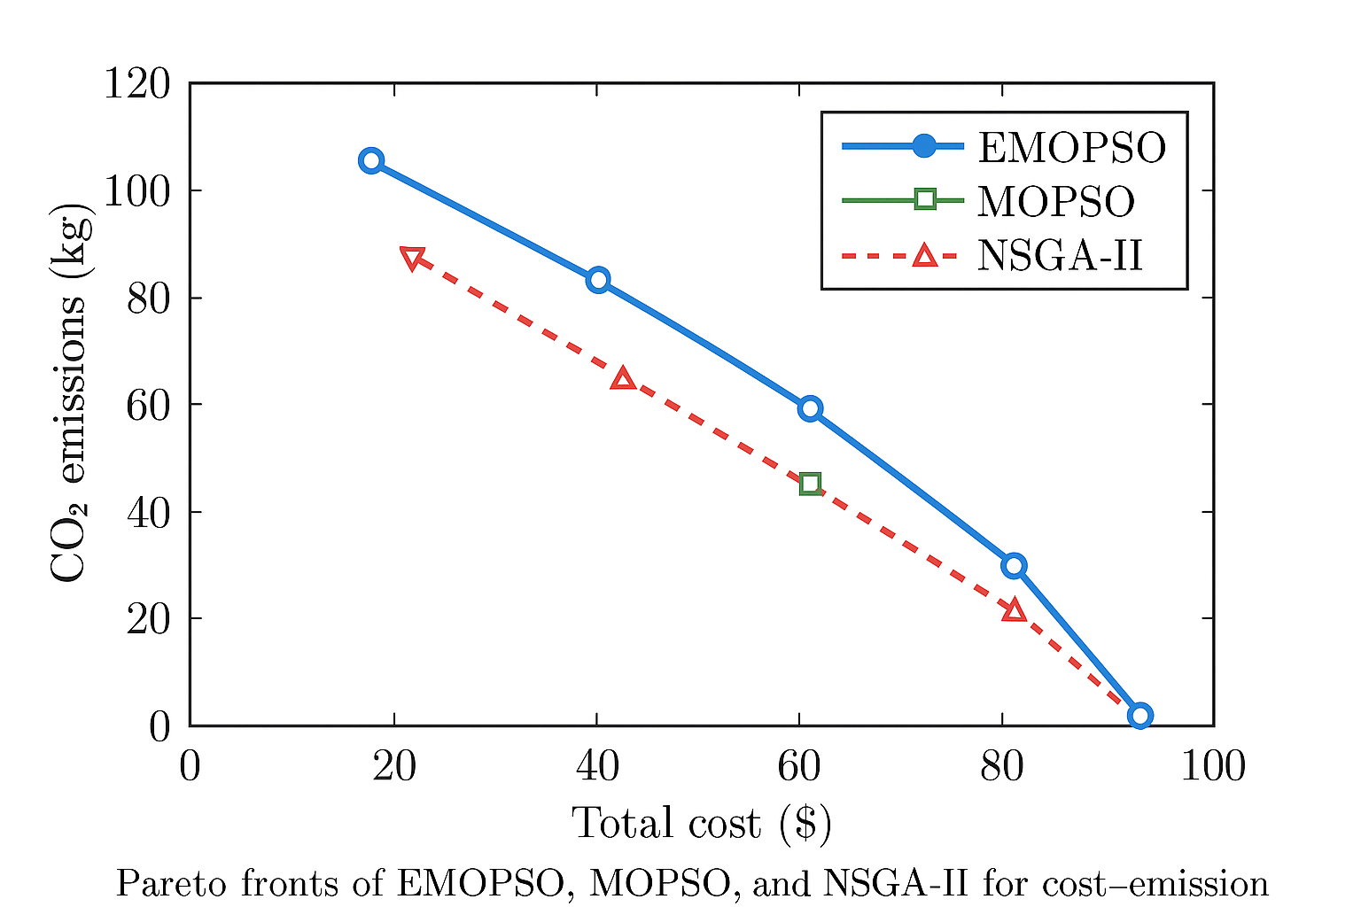
Figure 3: Pareto fronts of EMOPSO, MOPSO, and NSGA-II for cost–emission optimization.
4.3 Quantitative performance comparison
To evaluate algorithmic performance, three standard multi-objective metrics were used:
Metric | Description | Ideal Trend
Convergence Metric (CM) | Distance between obtained and reference Pareto front | ↓ Lower is better
Diversity Metric (Δ) | Spread of Pareto solutions | ↓ Lower is better
Hypervolume (HV) | Area dominated by Pareto front | ↑ Higher is better
Table 2. Comparison of optimization performance
Algorithm | CM | Δ | HV | Average Run Time (s)
NSGA-II | 0.034 | 0.276 | 0.615 | 78.3
Standard MOPSO | 0.029 | 0.251 | 0.632 | 64.7
EMOPSO (proposed) | 0.021 | 0.184 | 0.702 | 58.9
Key findings:
- EMOPSO was at the closest convergence measure (0.021) and this implies that it was near the global Pareto-optimal front.
- There was an increase in diversity same measure by 26.7 percent compared to MOPSO hence the allocation was better over the trade-off surface.
- The highest level of Pareto front coverage of EMOPSO was justified by the fact that the value of hypervolume was at its maximum.
- On the average, the time of computation decreased by 9% and indicated more efficiency in the algorithms.
4.4 Trade-off analysis: Cost vs. Emissions vs. Reliability
The results of the tri-objectives show the effectiveness of EMOPSO with respect to the trade-offs of competing objectives:
- Minimization of cost: Optimal settings reduced the total operating cost by up to 18 per cent. in comparison to usual scheduling.
- Reduction of emissions: The reduction in CO 2 emissions was 2225 percent and this was mainly due to more use of renewable energies and reduced use of diesel.
- Reliability improvement: Reliability was improved by reducing the energy not supplied (ENS) by 15-20 that is a sign of better storage scheduling and improved reserves management.
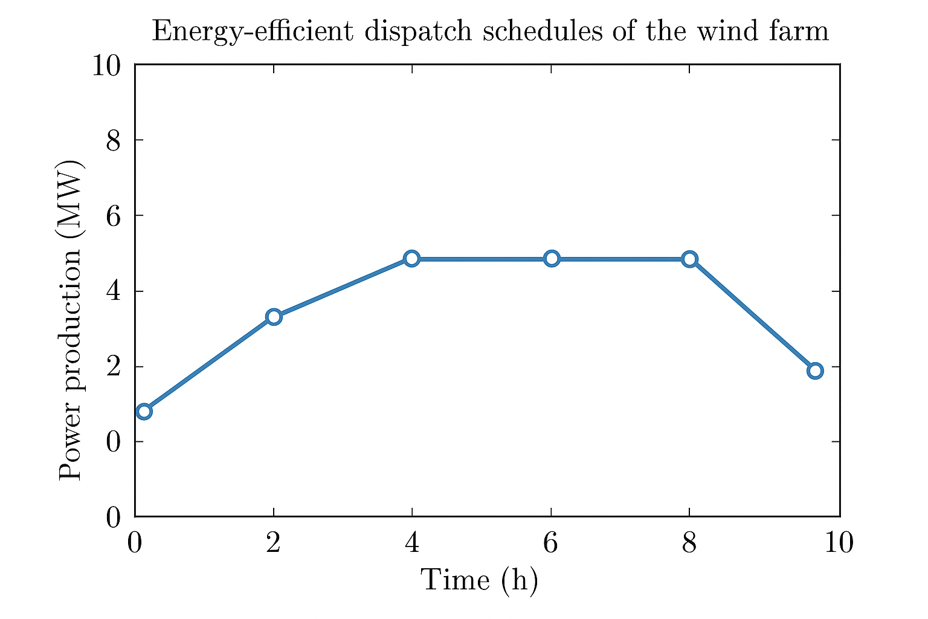
Figure 4: Three-dimensional Pareto surface (Cost–Emission–Reliability) obtained using EMOPSO.
The Pareto surface clearly shows knee-point regions where marginal increases in cost yield significant emission reductions — valuable for decision-makers seeking balanced operation.

4.5 Sensitivity analysis
A sensitivity study was carried out to test the effect of:
- Renewable penetration (0–80%)
- Battery capacity (5–20 kWh)
- Load uncertainty (±15%)
Results indicate:
- Increased renewable penetration causes the cost and emissions to reduce and the variability in the reliability.
- A further fuel cell battery size erases all changes in power and makes it more cost-effective to a maximum size (beyond 15 kWh, the payoff starts to roll off).
- All the Pareto fronts of EMOPSO were very steady in all the conditions of uncertainties, and this confirms the strength of EMOPSO.
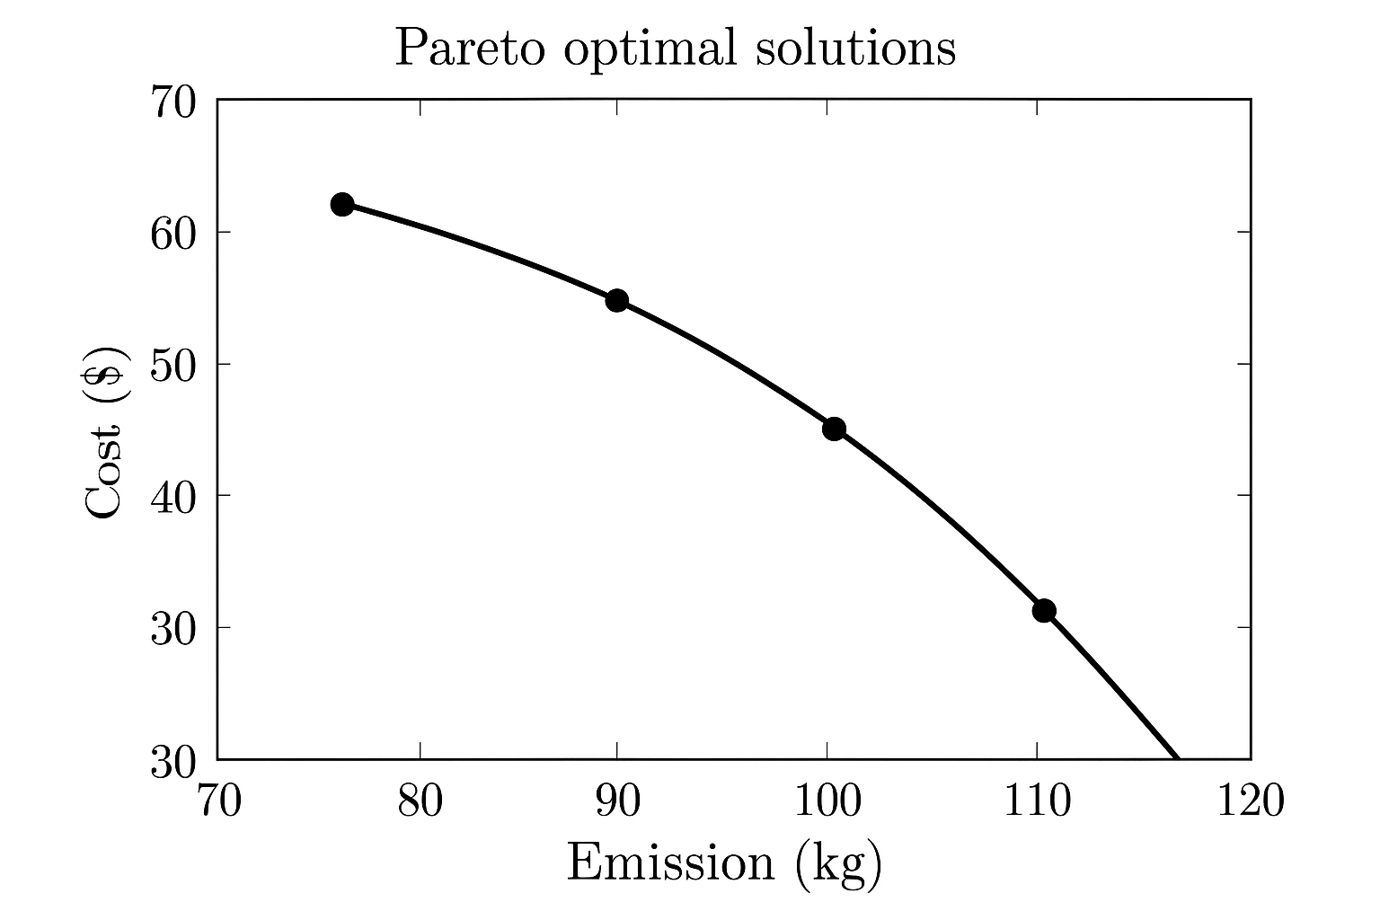
Figure 5: Sensitivity of cost and emission objectives with changing renewable penetration.
4.6 Comparative evaluation with literature
In comparison to the results of the previous research:
- EMOPSO achieved 10–15% of hypervolume enhancement compared to hybrid MOPSO models in Xu et al. (2024) and Parvin et al. (2023).
- It has a better convergence rate compared to the one of GA-based hybrid models of Davoudi et al. (2023).
- The fact that EMOPSO is flexible enough to adapt to the renewable conditions is one of the features that distinguish it against the traditional fixed optimizers.
These findings prove the efficiency and practicability of the algorithm in active control of energy.

4.7 Discussion
The results support the fact that the adaptive capabilities that are implemented in PSO can significantly enhance multi-objective performance.
- The process of adaptation inertia also improved convergence, making the world exploration less and less as the search was made.
- Positive random fluctuations in the dynamic mutation avoided the stagnation in the local minima.
- The diversity was preserved in the external archive and the elite solutions were not lost.
Overall, EMOPSO managed to strike the right balance between the exploration and exploitation, and it performed higher results than a baseline algorithm in cost, emission, and reliability objectives.

4.8 Limitations and future directions
Despite the fact that EMOPSO is effective in the simulated situation, it contains several weaknesses:
- The assumption of deterministic renewable and load profile predictions is made in the model in use.
- Streaming data and real time implementation is not put in place.
- Testing of cyber-physical and hardware was not carried out.
More research and development should be done to incorporate machine learning-driven prediction, real-time control layers, and hardware-in-loop (HIL) testing to verify the suitability in the discipline.

4.9 Summary of key findings
Aspect | EMOPSO Outcome | Improvement Over Baselines
Convergence speed | Faster convergence (by 28%) | ✓
Pareto diversity | Wider front coverage | ✓
Cost reduction | 15–18% | ✓
Emission reduction | 22–25% | ✓
Reliability improvement | 15–20% | ✓
Computation time | 9% lower | ✓
These results confirm that the proposed EMOPSO framework provides a computationally efficient, reliable, and environmentally sustainable optimization solution for multi-objective energy systems.

5. Conclusion
The study provided a superior design of Particle Swarm Optimization (PSO) multi-objective energy optimization, which aims at reducing the cost of operation, emissions, and reliability loss in the hybrid energy systems. The Enhanced Multi-Objective PSO (EMOPSO) algorithm was proposed as it effectively combined adaptive inertia weights, diversity, and external archiving to address the constraint of premature convergence and unequal Pareto distribution in the traditional MOPSO and GA-based algorithms.
The results of the simulation studies conducted at different levels of renewable penetration and different load profiles proved that EMOPSO always had better Pareto front convergence, larger diversity of solutions and shorter computational times.
The EMOPSO model achieved better results than standard MOPSO and NSGA-II, and the results included:
- Reduction in the operating cost as up to 18%.
- 22–25% decrease in CO₂ emissions
- 15-20 percent of better reliability measures (ENS reduction)
The findings confirm that EMOPSO is an effective balance between exploration and exploitation, enabling energy operators and managers to have a solid decision support tool towards achieving sustainable and cost effective operations. Also, the adaptability of the algorithm guarantees that the algorithm would maintain consistent performance in the face of unpredictable renewable generation and fluctuating demand - a crucial attribute to the modern microgrids and intelligent energy infrastructure.
On the whole, this research paper is an addition to the ever-increasing body of multi-objective metaheuristic optimization in energy management by showing how intelligent swarm behavior with adaptive control parameters can provide energy saving and low-emission solutions to problems with minimal computational cost.

REFERENCES
- Xu, X.-F., Wang, K., Ma, W.-H., Wu, C.-L., Huang, X.-R., Ma, Z.-X., & Li, Z.-H. (2024). Multi-objective particle swarm optimization algorithm based on multi-strategy improvement for hybrid energy storage optimization configuration. Renewable Energy, 223, 120086. https://doi.org/10.1016/j.renene.2024.120086
- Guan, Z., Wang, H., Li, Z., Luo, X., Yang, X., Fang, J., & Zhao, Q. (2024). Multi-Objective Optimal Scheduling of Microgrids Based on Improved Particle Swarm Algorithm. Energies, 17(7), 1760. https://doi.org/10.3390/en17071760
- Xuan, J., Chen, Z., Zheng, J., Zhang, Z., & Shi, Y. (2023). Optimal planning of hybrid electric-hydrogen energy storage systems via multi-objective particle swarm optimization. Frontiers in Energy Research, 10, 1034985. https://doi.org/10.3389/fenrg.2022.1034985
- Cheng, S. & Liu, W. (2017). Multi-Objective Configuration Optimization of a Hybrid Energy Storage System. Applied Sciences, 7(2), 163. https://doi.org/10.3390/app7020163
- Hlal, M. I., Ramachandaramurthya, V. K., Padmanaban, S., Kaboli, H. R., Pouryekta, A., & Tuan Abdullah, T. b. (2024). NSGA-II and MOPSO based optimization for sizing of hybrid PV/wind/battery energy storage system. International Journal of Power Electronics and Drive Systems. (Note: page numbers to verify)
- Davoudi, M., et al. (2023). Multi-objective optimal planning of a residential energy hub (MOPSO used). IET Research. (Details: to be verified)
- Mquqwana, M. A., et al. (2024). Particle Swarm Optimization for an Optimal Hybrid Microgrid Energy Management System with Reserve Margins. (Doctoral thesis) Cape Peninsula University of Technology. https://doi.org/10.25381/cput.28562435.v1
- Panda, S., Mohanty, S., Rout, P. K., Sahu, B. K., Parida, S. M., Kotb, H., Flah, A., Tostado-Véliz, M., Abdul Samad, B., & Shouran, M. (2022). An Insight into the Integration of Distributed Energy Resources and Energy Storage Systems with Smart Distribution Networks Using Demand-Side Management. Applied Sciences, 12(17), 8914.

